Question (1): For the circuit shown in Figure (1), find the current through each resistance using Node Analysis (10 marks)
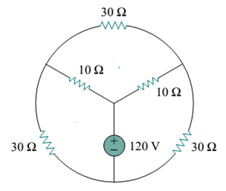
Figure (1)
Question (2):
In the diagram in figure (2), $v\left(t\right)=5Sin\left(10t+{15}^{o}\right)volt$ and
$i\left(t\right)=(1+j)$ Ampere. What is the type of the impedance of the BOX? Explain your answer. (5marks)
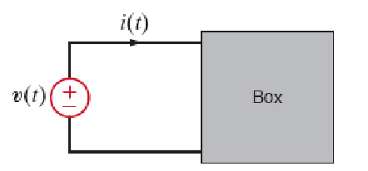 | Figure (2)
Question (3): A series R-L circuit connected with AC supply. If the magnitude of the inductive reactance was twice the value of pure element, find the power factor. (5marks)
$\boxed{2}$ | $\boxed{3}$

